Development Aspects
Prepared by: TSc.

User Interface
Hvordan præsenterer produktet sig for brugeren rent betjenings mæssigt? Skitsér for- og bagpladen, og beskriv hvordan apparatet skal forbindes til “omverdenen”. Beskriv hvordan apparatet betjenes i alle situationer

Mechanical Design/Styling
Hvordan ser apparatet ud? Størrelse og vægt? Anvendte farver, knapper og displays? Passer det design mæssigt med andre PTV (eller andre) apparater, det må forventes, det skal kunne arbejde sammen med?

Technical Description
Beskrivelse af apparatet og de anvendte kredsløb på - mindst - blok-diagram-niveau.

Main Instrument Functions

Instrument Block Diagram

Description of Instrument Block Diagram

PT 86xx BlackBurst generator with VITC timecode Option

Main Functions
The diffenrent signal-types present in the ‘old’ BB-generator shall be available in the ‘new’ generator.
Included in the option are:
- Four black and burst outputs.
- Running both G / M systems.
- Time Code (VITC) Vertial Insertion Time Code with full configuration of userbits on each channel. (IEC 461)
- VITC timing offset in step of frames.
- Holding level detection information for the master in the onboard controller.
- Phase on the black is about 0.18 degree (360/2047) interval on each channel.
- Timing with about 0.14ns resolution. (resolution better than 74ns.)
- Addition of field 1 pulse.

Product requirement:

Four outputs included in the option

Black Burst outputs BNC individually timeable
Output impedance: 75 Ω ±0.5 Ω
Return Loss: >36 dB, to 5 MHz
Amplitude: Sync -300mV/-286mV ±2%
Timecode +550 mV. (G) / +570 mV. (M) ±2.5%
Timing range 625/50 ± 4 field referring to genlock timing
Timing range 525/50 ± 2 field referring to genlock timing
Timing resolution 0.5o of fSC
Timing offset when timing set to 0 < 1.5o of fSC
S/N Ratio 60dB
Jitter ± 0.5 ns

Block Diagram
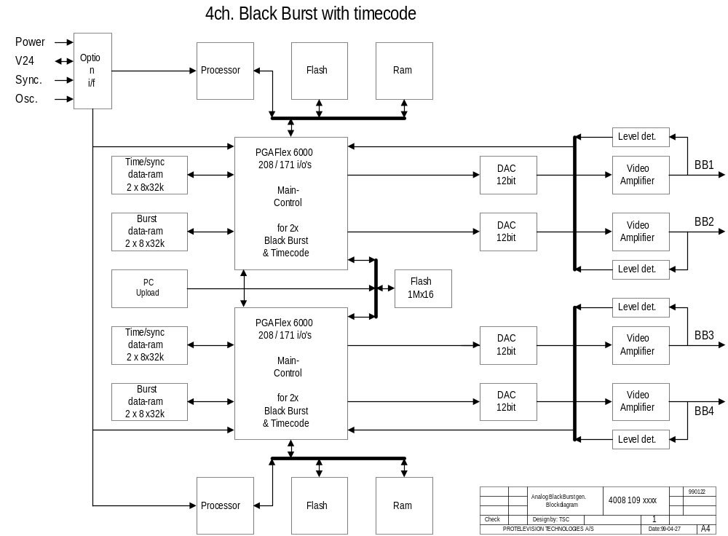

Block Diagram Description
The block diagram consists of:
1. Two Processor systems with flash PROM and RAM.
2. Two PGA’s (Main control) with logic to control the four BlackBurst and the TimeCode signals.
3. Dac’s and output drivers for the BNC connectors.
4. Level detectors for each channel
5. TimeCode, sync and BlackBurst data in flash.

1. The processors handles the communications with the master processor (ControllerCard), e.g. commands, level detector, errors and controls the four blackburst generators.
The communication speed (three times of that to day), TimeCode handle and keeping level-information are new functions for the processors to handle. Therefore the processor-system on the option will be a 16-bit system and have an incease of prom speed to meet the new requirements.
These requirements lead to the necesary of two processor-systems to handle four BlackBurst generators.

2. The PGA’s (Main control) contains logic to control the four BlackBurst generators with the following main functions:
- communicate with the controller-system.
- calculate the eight CRC bits for the TimeCode.
- loading TimeCode, sync and burst ram’s.
- running data sequenzer for the dac’s.
The priciple of Main control is to load burst, sync and timecode data from the flash into the ram’s under initialization of the balckburst-generator. When the generator starts, the Main control will get data from the ram’s and when the burst-data has been taken the Main control will start filling the burst-ram’s with the new burst-phase-data for the next line. The sync and timecode data will stay the same as long as the blackburst-generator is on.

3. For each BlackBurst channel the dac’s are 12 bit’s to maintain the accuracy when rising the amplitude from (-300 to +150mV) to (-300 to +700 mV). Ther dac’s are supplyed from 3V to reduse the power used by the BlackBurst.

4. The detectors consist of a window comparator followed by detection logic which will have connection to the PGA, where the information are stored. The processor can read the level dectectors in a register in the PLD.

5. The video-amplifier moduls consist of two op-amps with a filter in between and an output circuit to obtain 75 ohm on the BNC outputs.

New Components and Technologies
All digital and analog components will have only +3.3 V supply to reduce power consumption.
Capacitors as well as inductors shall be smd types. Electrolytic capacitores are included and have the wanted lifetime of minimum 10 years at approximately 65°C .
Use of flash prom’s to make data reprogramable.

Her beskrives nødvendige nye komponenter og anvendte teknologier - ikke blot kredsløbsmæssigt men også produktionsmæssigt.

Development Time & Cost
Development time 4 ch. : Approx. 28 weeks excl. software.

Prototype costs 4 pcs : (Dkr.)
PCB  layout | 10.000,-  20.000,-
Components | 11.000,-
Instruments:  DMM  VITC reader | 4.000.-  0.- *
Total hardware costs | 51.000,-
* The VITC/LTC reader price and calculation is shown in Pt5220/work/felles/equip.doc

Her angives det estimerede ressourceforbrug til gennemførelse af de planlgte udviklingsfaser:
Interne udviklingstimer, externe konsulenttimer, udviklingsmaterialer herunder prototyper opsplittet på faser.

Production / test Cost

Cost (4ch.): kr. 2008,- incl. PCB ( kr. 502,- each channel, option )

Approx. test time requirement for the option
Test time | 0,2 hour
Repairment | 0,5 hour
Flash programming , 10min / Mbyte upload | 0,1 hour
Burnin and test | 0,3 hour
Test equipment handle | 0,1 hour
Total test time | 1,4 hour
Estimeret produktionsomkostning pr. stk. i de forventede kvantiteter:
Materialepris, montageomkostning, testomkostning

Test equipment : (Dkr.)
Flash / PGA load via PC | 15.000,-
Total test-equipment costs | 15.000,-

